ICTGAM433

Rendering Software Preparation

IMMERSIVE STUDIOS

ASSESSMENT 2

Xihao Chen | 30053752

2022

Table of Contents

Project Requirements Summary 2

Annotated Images 2

Output Properties (Image Resolution, Aspect ratio, Pixel Ratio) 2

Anti-Aliasing/Visual Effects Settings 3

Sampling Settings 3

Light Paths Settings 3

Film (Anti-Aliasing Pixel Filter) 4

Performance Settings 4

Colour Management Settings 5

Compositing Settings 6

World Lighting Settings 6

Images/Textures Linkage 7

Linked Images/Materials 7

Alpha Channels/Opacity Maps 8

Render Layers/Passes 9

References 10

# Project Requirements Summary

**Excerpt from Project Plan**

The requirements of the project are summarised below according to the design brief:

* A blender scene is supplied for rendering purposes, being used as a target for the future implementation of the assets into a game.
  + Materials may be changed as needed.
  + Compositing and any adjustments of assets are permitted.
* The rendering of **three** images each at a resolution of **1920 x 1080.**
  + The render times are expected to be less than **two (2) minutes**.
  + The result of the render is the main priority.
* Each image must have a different camera angle:
  + The camera angle must hide all 3D geometry artifacts.
  + No visible noise should be seen in each image render.
* Each image render result is saved as a **TARGA** file format, with a maximum file size of **800MB** for each file.

# Annotated Images

## Output Properties (Image Resolution, Aspect ratio, Pixel Ratio)

16:9 aspect ratio based on set resolution.

Aspect pixel ratio at default 1:1 for square pixels, which are used with modern displays.

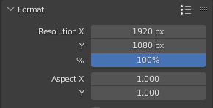

Resolution of 1920x1080 according to design brief constraints. One of the most common display resolutions for rendered images.

## Anti-Aliasing/Visual Effects Settings

### Sampling Settings

### Light Paths Settings

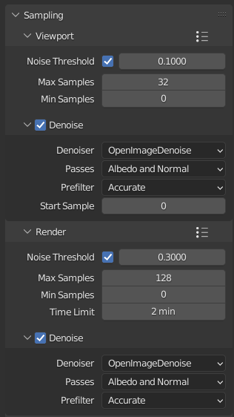

Viewport sampling settings set to 0.1 noise threshold, 32 samples and denoising enabled for less lag while in the “Rendered” viewport sampling mode.

Rendering sampling settings set to 0.3 noise threshold, 128 samples and denoising enabled for balanced image quality, anti-aliasing and rendering times. The time limit for renders is set to 2 minutes.

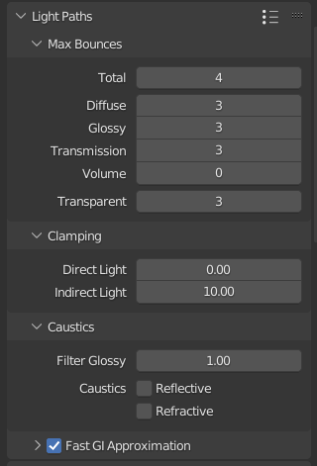

Max light bounces limited to 4 to reduce rendering time while preserving image rendering quality.

Clamped indirect light values to 10 to reduce the amount of “fireflies” noise artifacts produced during rendering.

Enabled to increase rendering speed.

### Film (Anti-Aliasing Pixel Filter)

### Performance Settings

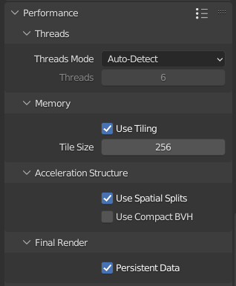

Enabling tiling and tile size set to 256 produced the quickest image rendering times.

Settings enabled to increase rendering speed, with a small hit on scene building speed from the “Use Spatial Splits” checkbox. “Persistent Data” is effective on static scenes.

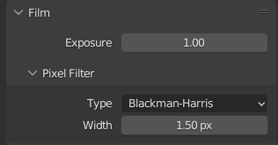

Pixel filter settings help fine-tune the strength of the “anti-aliasing” effect from the sampling settings.

### Colour Management Settings

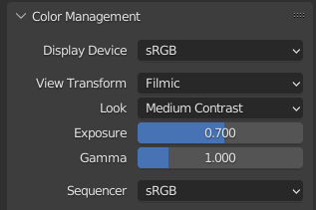

Colour management was adjusted to match the scene lighting with the background/overlay. Selected “Medium Contrast” and reduced exposure/gamma to 0.7 and 1 respectively.

### Compositing Settings

### World Lighting Settings

Denoising nodes to eliminate residual noise from source inputs.

Base render result for compositing use.

Background overlay for compositing use.

Glare to simulate “bloom” effect.

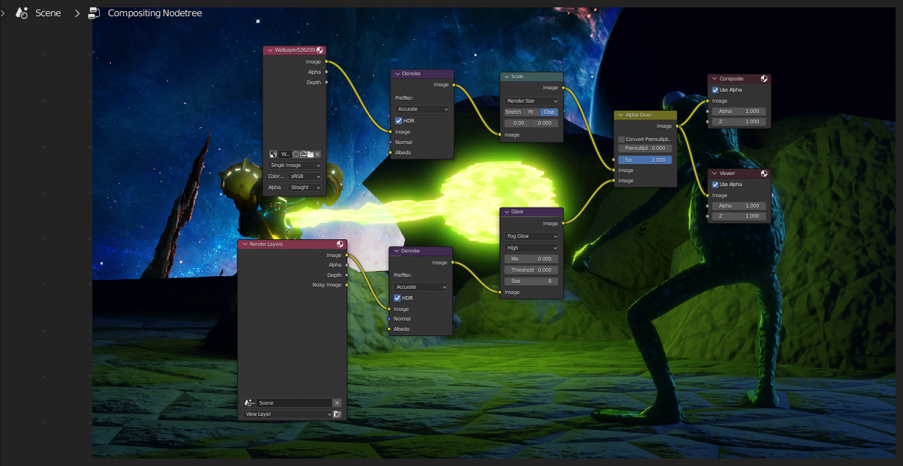

Viewer node to preview effects.

Composite output.

Alpha blend for seamless scene/background overlay overlap.

Scaling denoised image to fit render dimensions.

“Nishita” sky texture shading technique, a powerful shader to simulate world light. Includes various properties to adjust the sun position/rotation, environment and altitude.

Sky texture as background light.

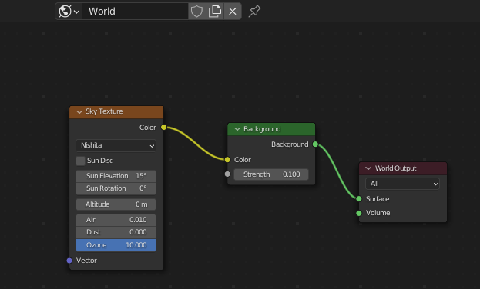

Lighting output.

## Images/Textures Linkage

### Linked Images/Materials

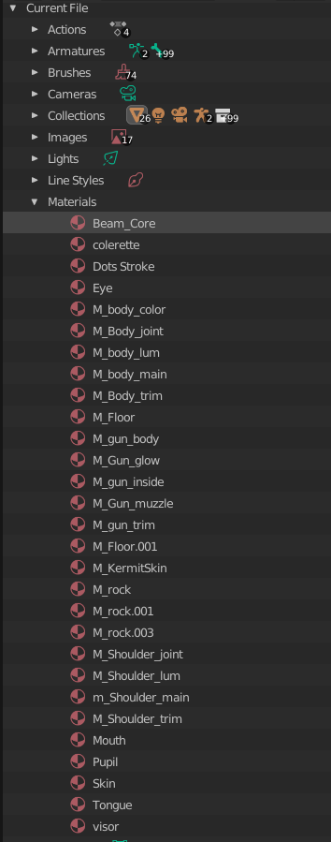

Material files with their respective image textures.

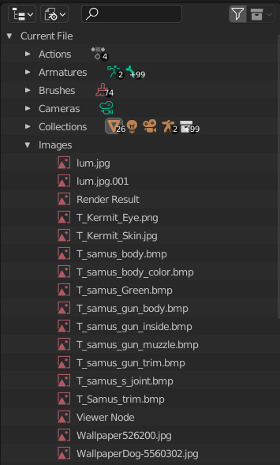

“Blender File” view displaying image files used for material textures/background overlays in the Blender scene. Removed two orphan files from the selection that couldn’t be relinked.

## Alpha Channels/Opacity Maps

Additional material settings to adjust blending and shadow modes, as well as backface display.

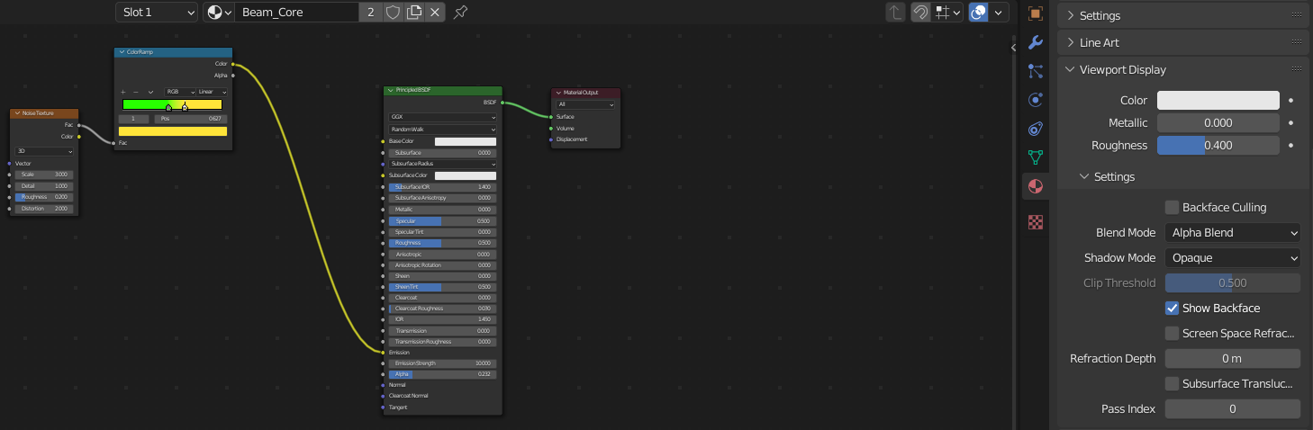

Adjustable alpha value for the “Beam_Core” material to control its opacity.

## Render Layers/Passes

Enabled light pass effects to improve picture quality while respecting the 2-minute rendering time constraint.

Alpha threshold which affects the enabled “Z” pass for surfaces equal to or less than the threshold value.

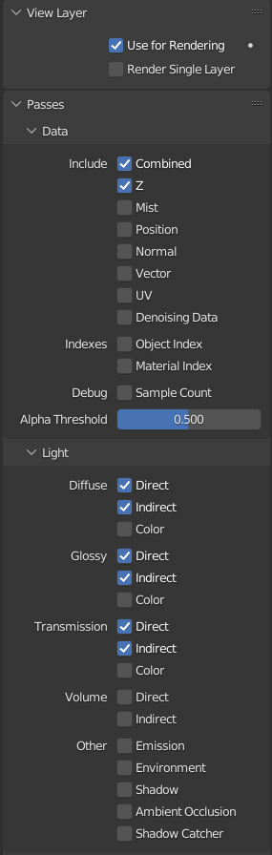

“Combined” and “Z” data passes enabled by default.

View layer enabled for use in image rendering.

# References

Blender Foundation. (2022, October 24). *Format*. Retrieved from Blender Documentation: https://docs.blender.org/manual/en/3.3/render/output/properties/format.html

Blender Foundation. (2022, October 24). *Sampling*. Retrieved from Blender Documentation: https://docs.blender.org/manual/en/3.3/render/cycles/render_settings/sampling.html